Room Light Controller

The purpose of this device is to collect and display relevant information about a room and based on that information turn on or off the lights.

Information collected and displayed on the LCD:

1. Whether the lights are on in the room
2. Whether motion has been detected
3. The temperature of the room

Other features:

1. LED light that whose brightness is inversely correlated with the brightness of the room
2. LED light that turns on when motion is detected
3. Servo motor that turns on the lights if motion has been detected and turns off the lights if motion has not been detected in the past 5 minutes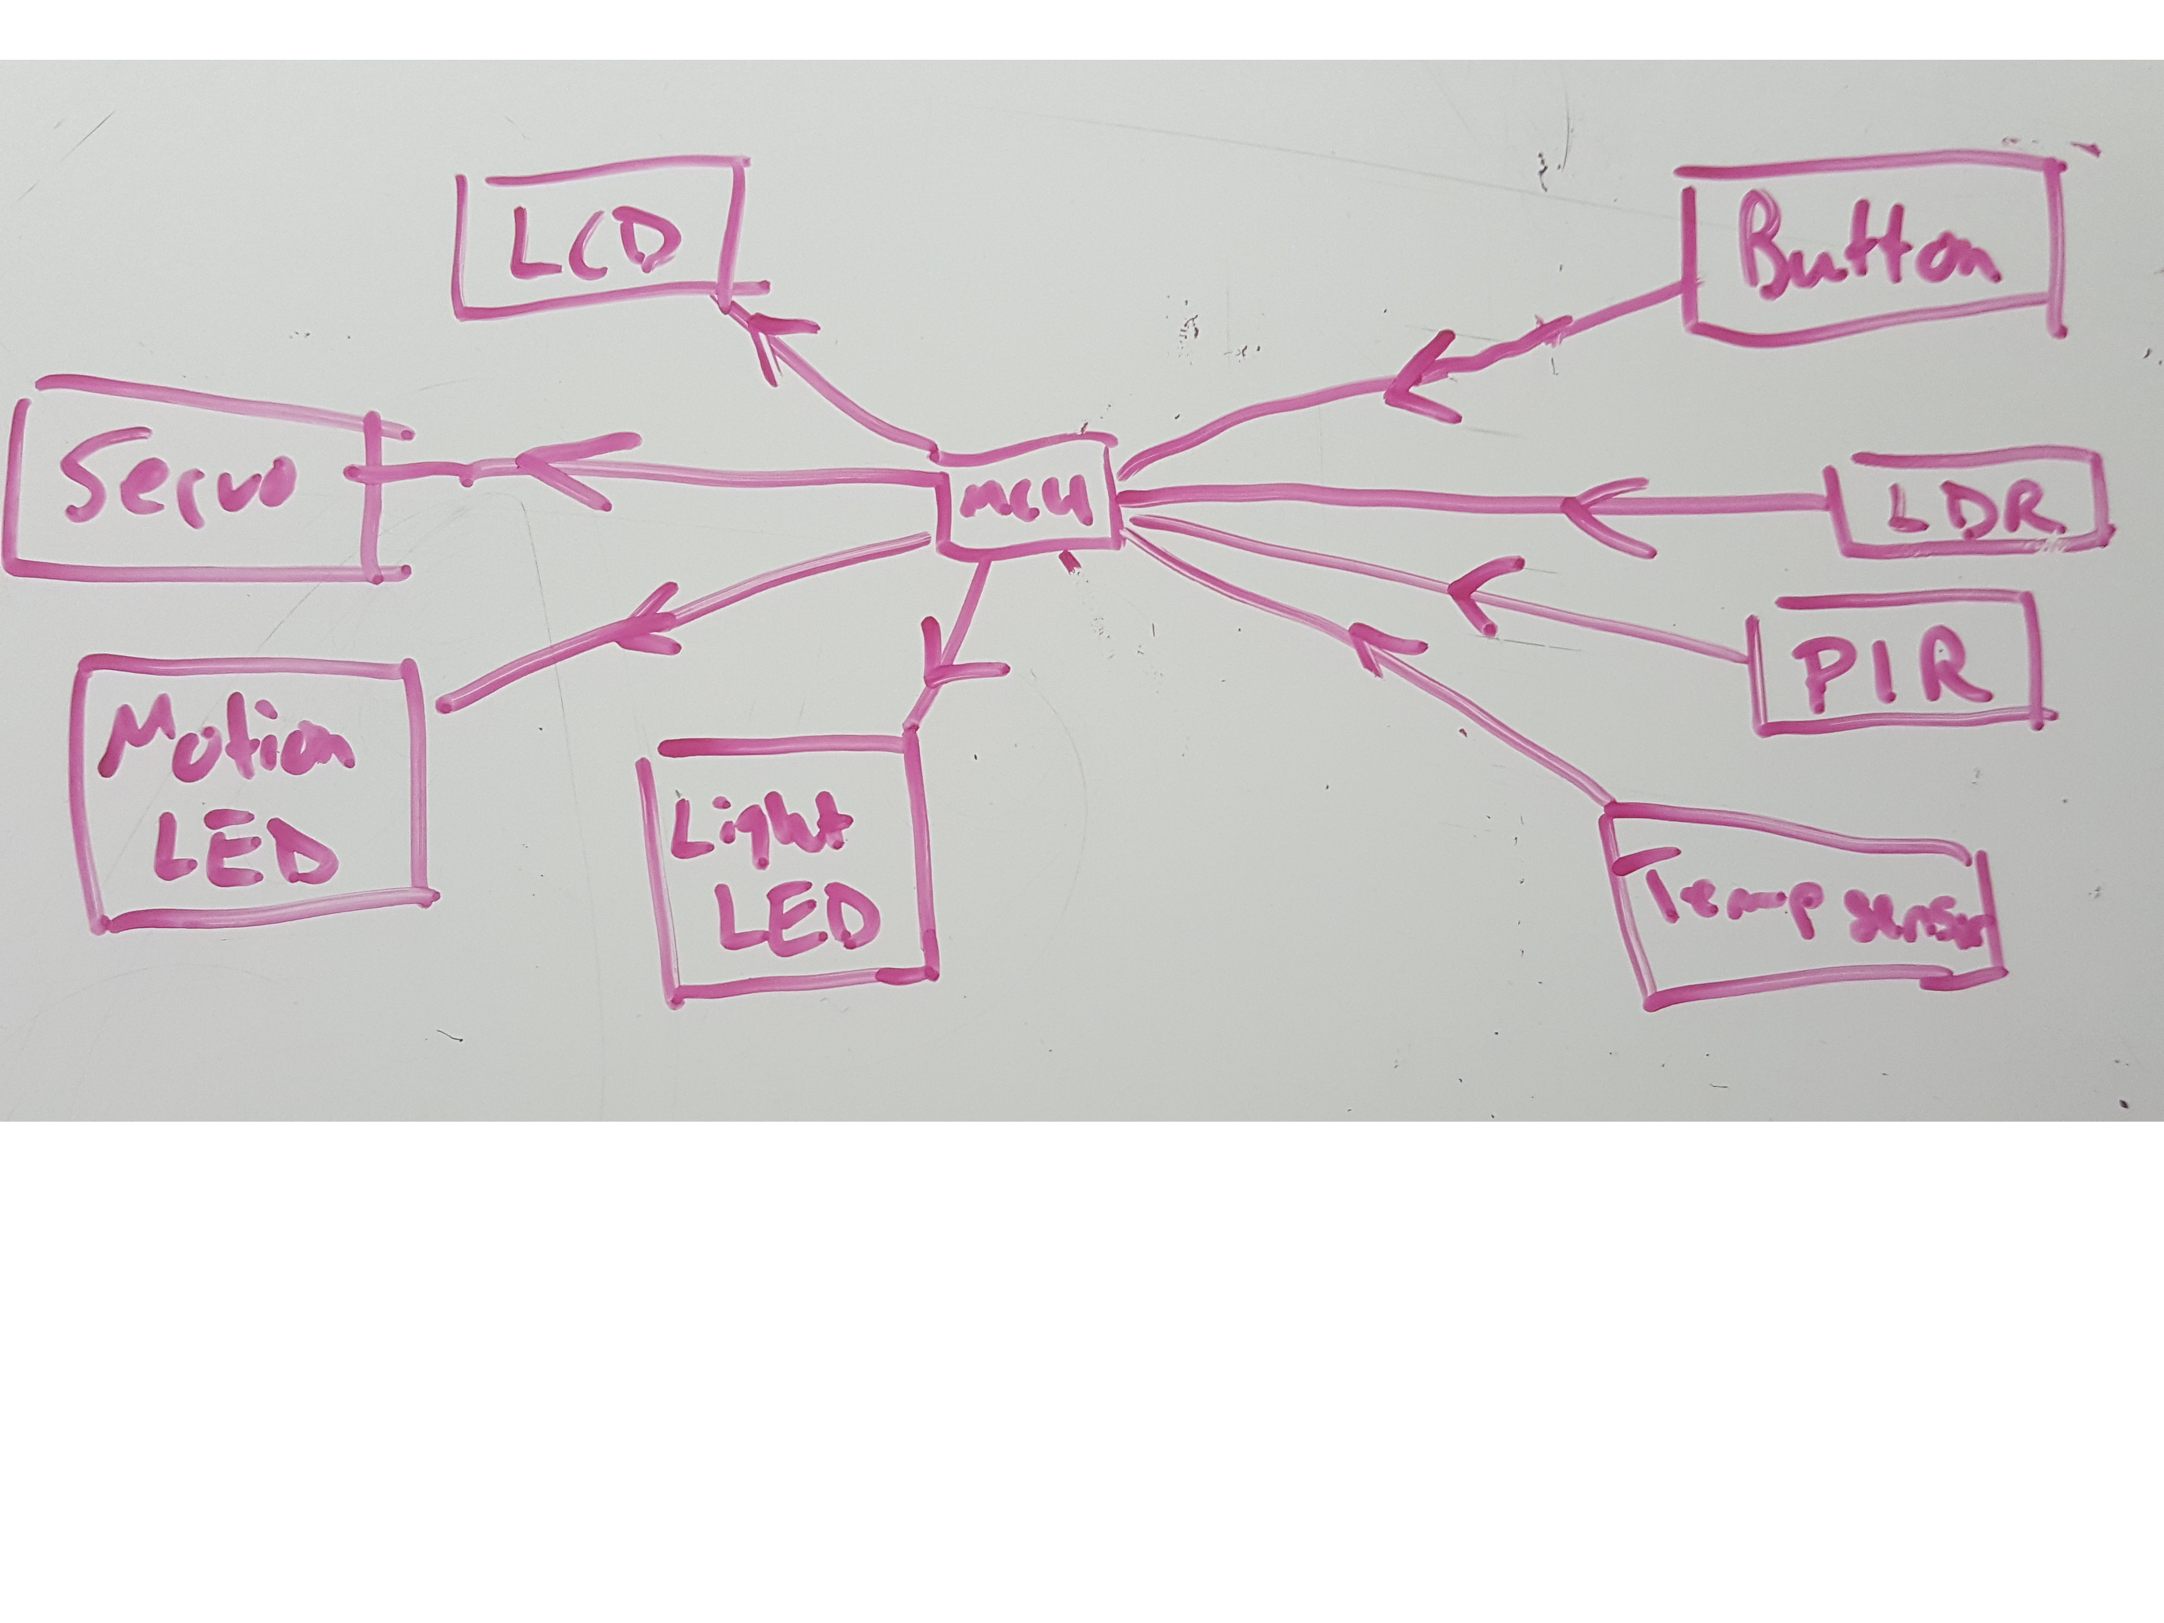
4. Push button to enable/disable the light control servo

At this time, we expect the use of the following major Peripherals:

1. GPIO
   1. Input from PIR
   2. Input from push button
   3. Output to LCD
   4. Output to Motion LED
2. 2 Analog Input Channels
   1. Input from LDR
   2. Input from temperature sensor
3. 2 PWM Channels
   1. Output to control Servo
   2. Output to Light LED